**Section One: Short response 40% (59 Marks)**

**Question 1 (5 marks)**

A hockey player attains a high metabolic rate during a game and much of the excess heat generated must be lost by sweating. During such a game, he develops excess heat at the rate of 568 joules per second. If 90.0 % of this heat must be lost by sweating, calculate the mass of sweat produced in a 25.0 minute session. Assume all of the sweat evaporates and the latent heat of vaporisation of sweat is 2.26 x 106 J kg-1.

|  |  |
| --- | --- |
| **Description** | **Total** |
| Q = P x t x ε/100  = 568 x (25 x 60) x 0.9 | 1 |
| = 766,800 J | 1 |
| Q = mLv , m = Q/Lv6 | 1 |
| = 766,800 / (2.26 x106) | 1 |
| = 0.339 Kg | 1 |
| **Total** | **5** |

**Question 2 (7 marks)**

A student heated a 750.0 g solid sample in an insulated container. An electric heating coil supplied heat energy at a rate of 20.0 J s-1. She measured the temperature of the substance at half-minute intervals. The data was then graphed as shown below.



(a) Which section (A-B, B-C, etc) of the graph represents: (2 marks)

(i) the solid warming up to its melting point? A-B (1 mark)

(ii) the gaseous substance increasing in temperature? E-F (1 mark)

(b) Which sections of the graph represent stages where: (2 marks)

(i) the average kinetic energy of the particles was increasing?

A-B, C-D, E-F (1 mark if all correct, no half marks )

(ii) the potential energy of the particles was increasing, whilst their kinetic energies remained constant?

B-C and D-E (1 mark if both written, no half marks )

(c) ESTIMATE the quantity of heat required to convert 1.0 kg of the solid, at its melting point, to a

liquid. (3 marks)

|  |  |
| --- | --- |
| **Description** | **Total** |
| Time = 1 to 1.1 min = 60 - 66 s | 1 |
| Quantity of heat to convert 0.75 kg of solid to liquid = 20 x 66  = 1320 J | 1 |
| Quantity of heat to convert 1.0 kg of solid to liquid = 1.0/075 x 1320  = 1.76 x 103 J | 1 |
| **Total** | **3** |

**Question 3 (7 marks)**

A fission reaction used in nuclear power plants is the splitting of uranium-233 through thermal neutron absorption. One possible fission event produces tellurium-133 and zirconium-97 as daughter isotopes.

(a) Complete the reaction by filling in how many neutrons are produced. (1 mark)

 +  →  +  + **4** + energy

Given:

Uranium-233 3.86846 × 10-25 kg

Tellurium-133 2.20632 × 10-25 kg

Zirconium-97 1.60872 × 10-25 kg

Neutron-1 1.67492 × 10-27 kg

1u = 1.66055 × 10-27 kg

(b) Determine the mass defect in atomic mass units (amu) that results from this reaction.

(4 marks)

|  |  |
| --- | --- |
| **Description** | **Total** |
| mass defect = m(reactants) – m(products)  = m(U-233) + m(n-1) – [m(Te-133) + m(Zr-97) + 4x m(n-1)] | 1 |
| = 3.86846 × 10-25 + 1.67492 × 10-27  – [2.20632 × 10-25 + 1.60872 × 10-25 + 4x (1.67492 × 10-27)] | 1 |
| = 0.0031424 x10-25 kg x 1.660055 x 10-27 | 1 |
| = 0.191u | 1 |
| **Total** | **4** |

(c) Calculate the energy produced by this reaction in MeV. (2 marks)

|  |  |
| --- | --- |
| **Description** | **Total** |
| E = m.d. x 931  = 0.191 x931 | 1 |
| = 178 MeV | 1 |
| **Total** | **2** |

**Question 4 (4 marks)**

(a) State the potential difference between: (3 marks)

Live and neutral: 240 V

Neutral and Earth: 0 V

Earth and Live: 0 V

|  |  |
| --- | --- |
| **Description** | **Total** |
| 240 V | 1 |
| 0 V | 1 |
| 0 V | 1 |
| **Total** | **3** |

(b) Provide one of the benefits of a circuit breaker over a fuse. (1 mark)

|  |  |
| --- | --- |
| **Description** | **Total** |
| Can be reset instead of needing replacement  OR  Cheaper than replacing fuses  OR  Can trip the circuit much faster  OR  Cannot be tampered with as per part (a) | 1 |
| **Total** | **1** |

**Question 5 (6 marks)**

The following diagram shows the original patent for a vacuum thermos flask.

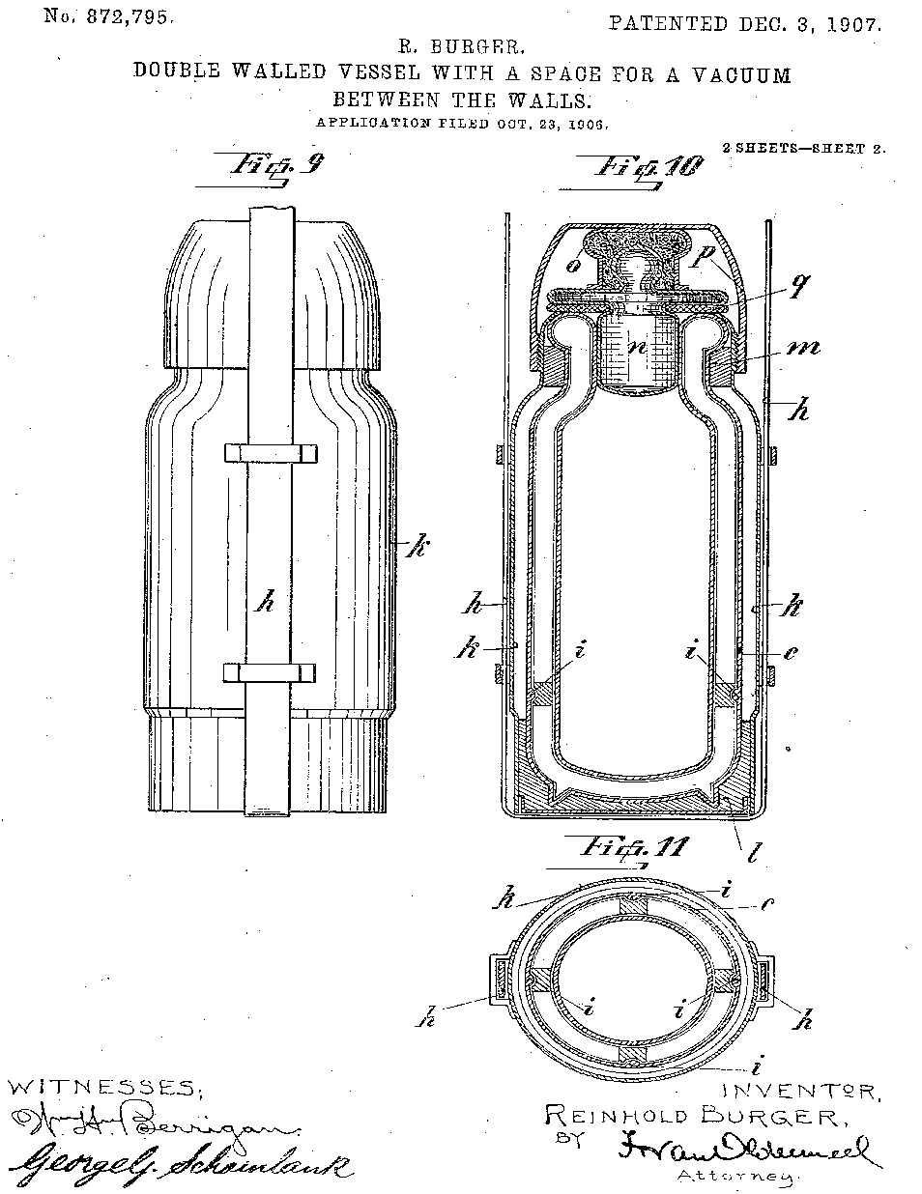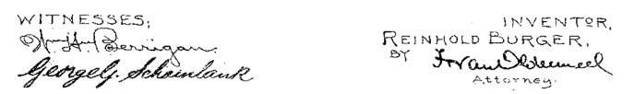

*n :plastic stopper*

*i :foam sponges*

*p : plastic cup*

*q : rubber seal*

*k : evacuated space*

*h : white walled plastic*

*c : silvered inner liner*

Explain three design features that reduce heat lost. You are response must include all three heat transfer processes.

|  |  |
| --- | --- |
| **Description** | **Total** |
| n or p: traps air in the thermos. Still air is an insulator | 1 |
| and prevents transfer of heat **away** from the flask by convection | 1 |
|  |  |
| k: Evacuated space has no molecules/vacuum | 1 |
| and prevents heat lost via convection and conduction. | 1 |
|  |  |
| h: white walled surface has a lower emissivity | 1 |
| and reduces the rate of radiation emitted from the thermos | 1 |
|  |  |
| c: silvered inner reflecting surface. Reflects radiated infrared radiation back towards body | 1 |
| To reduce rate of heat loss. | 1 |
|  |  |
| i: foam sponges are made of a non-metal which is thermally insulating | 1 |
| which reduces the rate of heat lost via conduction | 1 |
| **Total** | **6** |

**Question 6 (7 marks)**

(a) Draw in the space below, so that points A and B are at either end of the effective

resistance. Label the resistors in your diagram R1, R2, R3 ….etc. If you used fewer

resistors, use fewer labels. (3 marks)

|  |  |
| --- | --- |
| **Description** | **Total** |
| R1 = 2.00 Ω  R2 = 2.00 Ω  R3 = 2.00 Ω  R4 = 2.00 Ω |  |
| 2 in series and 1 in parallel | 1 |
| neat straight lines, drawn with ruler | 1 |
| appropriately labelled | 1 |
| **Total** | **3** |

(b) Calculate the voltage drop across each of the resistors and write the value in the table

below. If you used fewer than five resistors, leave the unused resistor box(es) blank.

(4 marks)

|  |  |
| --- | --- |
| **Description** | **Total** |
| IT = VT / R­T  = 9.00 / 5.00  = 1.80 A | 1 |
| V1 = V2 = IT.R  = 1.80 x 2  = 3.60 V | 1 |
| VT = VP + VR1 + VR2  9 = VP + 3.6 + 3.6 | 1 |
| VP = 1.80 V |  |
| **Total** | **3** |

|  |  |
| --- | --- |
| **Resistor** | **Voltage drop (V)** |
| R1 | 3.60 |
| R2 | 3.60 |
| R3 | 1.80 |
| R4 | 1.80 |
| R5 |  |

**Question 7 (6 marks)**

(a) Calculate the gradient of the graph for the period of time where the temperature is changing. (3 marks)

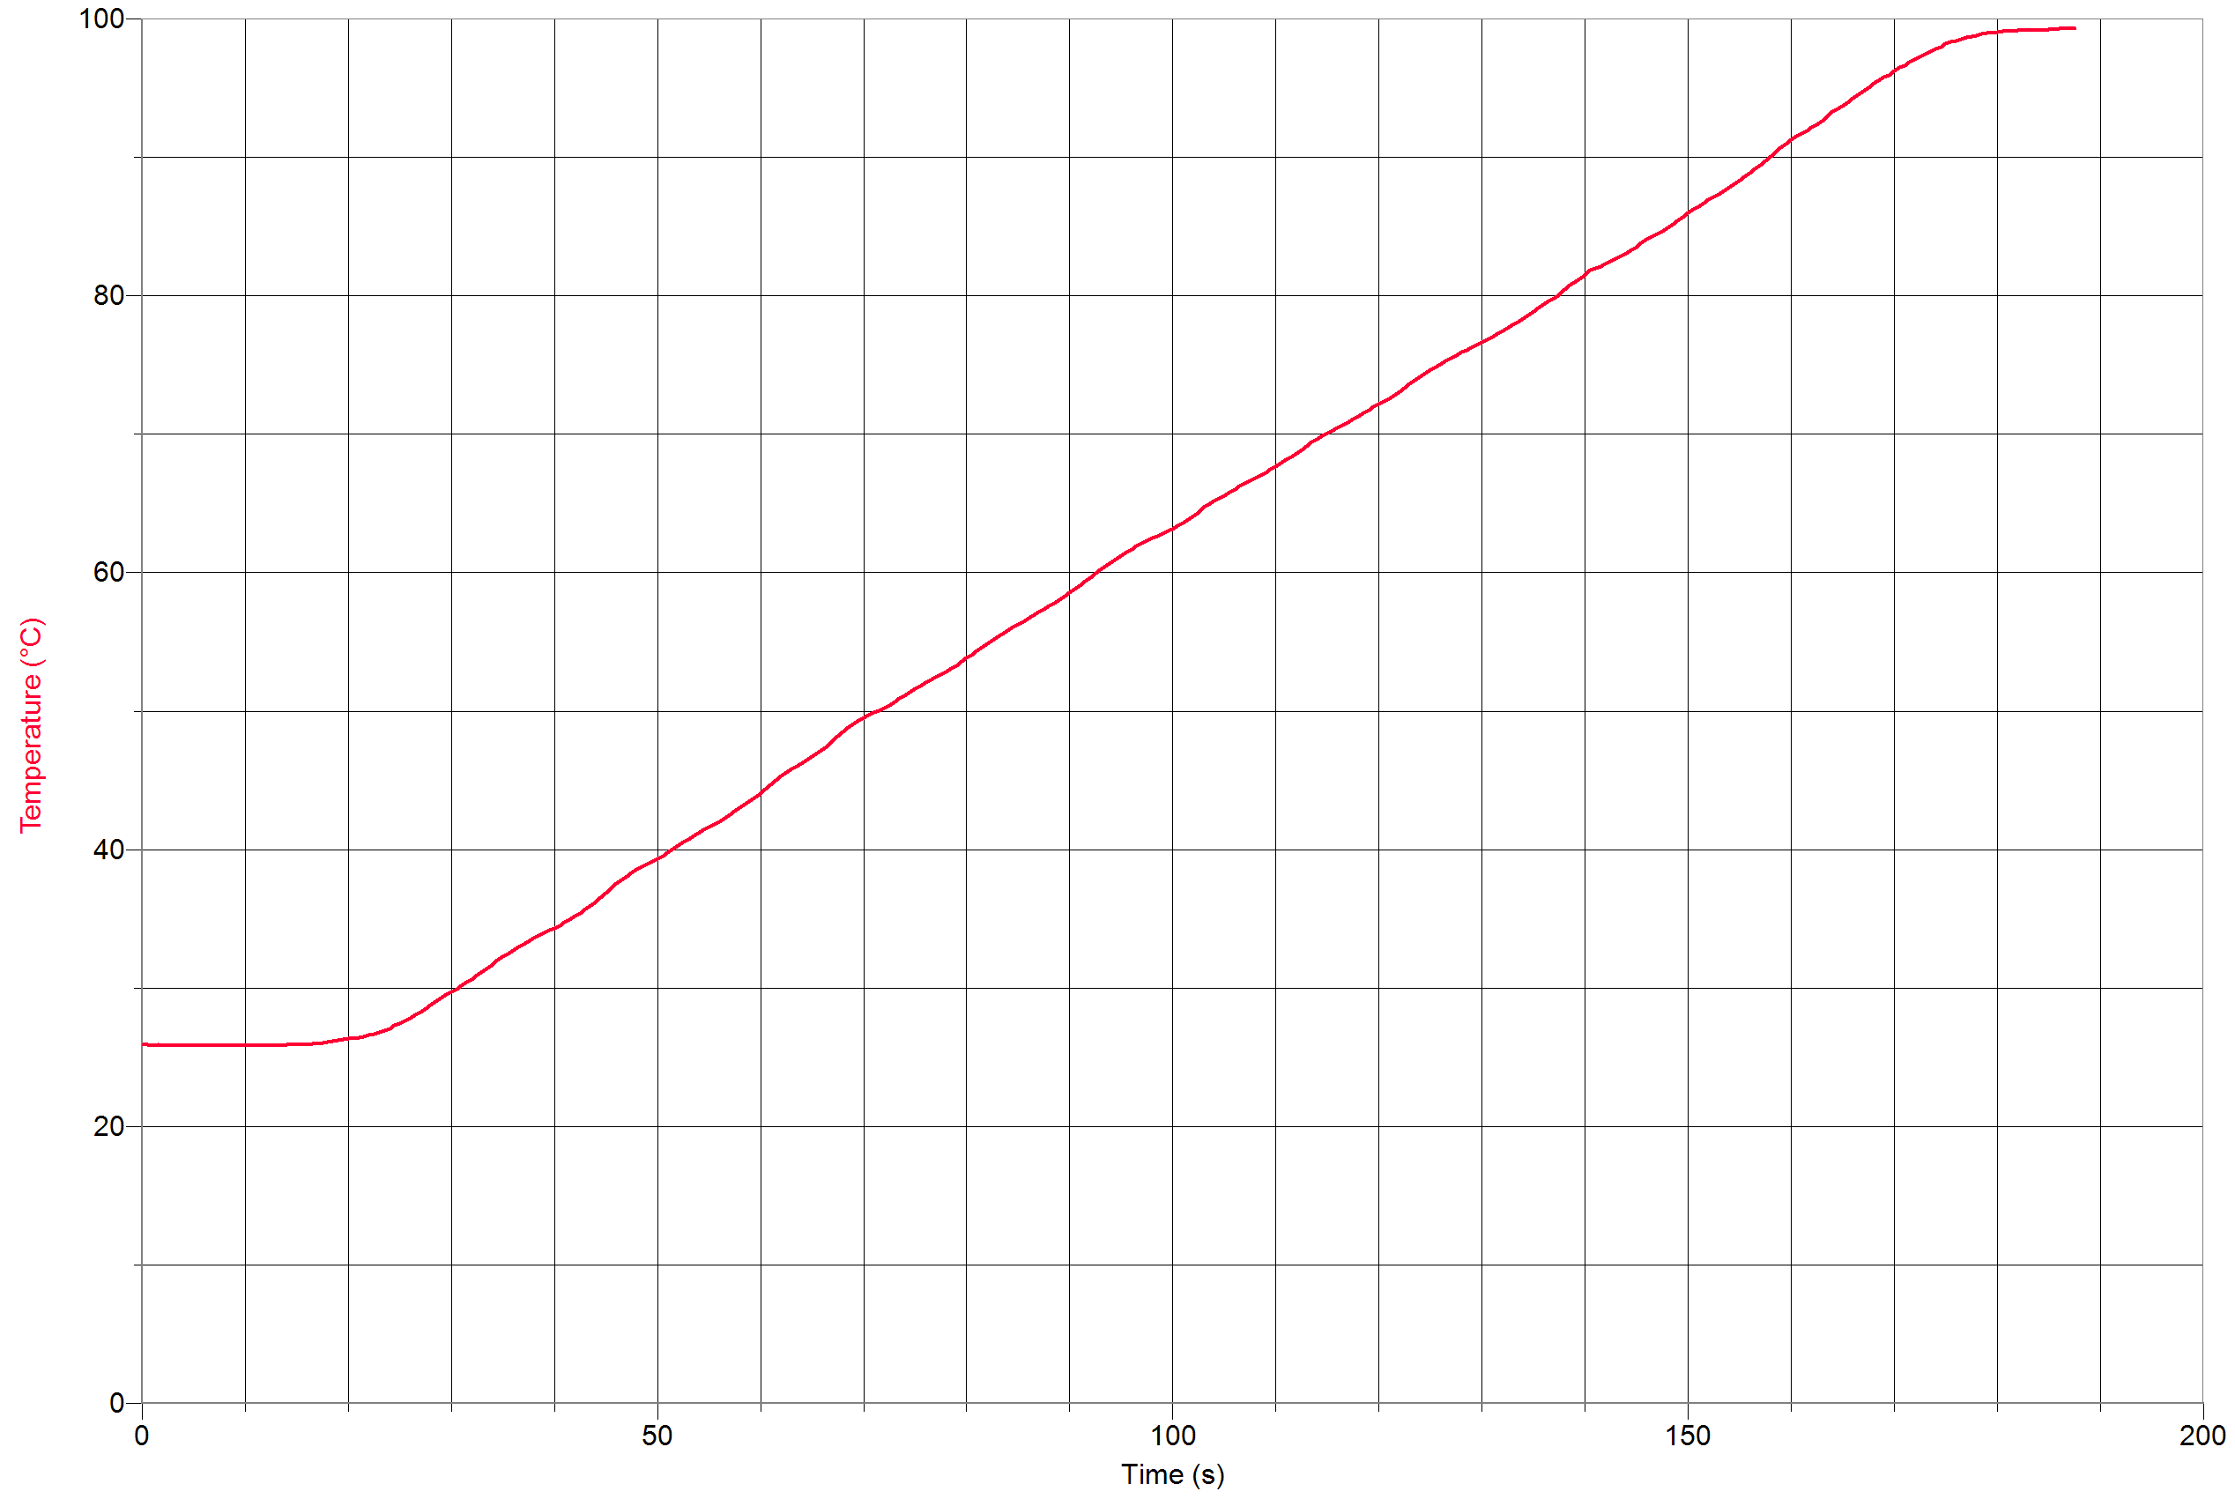

(30,30)

(160, 91)

|  |  |
| --- | --- |
| **Description** | **Total** |
| m = y2-y1 = 91 – 30  x2-x1  160 - 30 | 1 |
| = 0.47 °C | 1 |
| °C s-1 (units present) | 1 |
| **Total** | **3** |

(b) Use the gradient to calculate the effective power of the heating element. (3 marks)

|  |  |
| --- | --- |
| **Description** | **Total** |
| P = ΔQ / Δt = mc(ΔT/Δt), gradient = ΔT/Δt | 1 |
| = 0.500 (4180) 0.47 | 1 |
| = 980 W | 1 |
| **Total** | **3** |

**Question 8 (5 marks)**

A 135 g block of aluminium is heated in an oven and placed into an insulated vessel containing 1.10 kg of water at 19.0 °C. The final temperature of the aluminium and water mixture was 35.0 °C when they reached thermal equilibrium. Assuming no water boils off, calculate the initial temperature of the aluminium block.

CAL = 900 J kg-1 K-1

Cwater = 4180 J kg-1 K-1

|  |  |
| --- | --- |
| **Description** | **Total** |
| Qg + QL = 0  mc $∆T+$ mc $∆T$ = 0 | 1 |
| 1.10(4180)(35.0-19.0) + 0.135(900)(35.0 – Ti) = 0 | 1 |
| 73568 + 121.5(35.0 – Ti) = 0  73568 + 4252.5 – 121.5 Ti = 0  77820.5 = 121.5Ti | 2 |
| 640 °C | 1 |
| **Total** | **5** |

**Question 9 (8 marks)**

(a) Describe what is occurring in the nucleus when a radionuclide undergoes beta + decay.

(2 marks)

|  |  |
| --- | --- |
| **Description** | **Total** |
| a proton turns into a neutron | 1 |
| and emits a beta particle, an antineutrino and energy | 1 |
| **Total** | **2** |

(b) Provide **one** similarity and **one** difference between alpha and beta negative decay.

(2 marks)

|  |  |
| --- | --- |
| **Description** | **Total** |
| Both emit energy / convert mass to energy  Both result in a reduction in mass  Both particles are emitted with Ek  Both emit electrically charged / ionizing | 1 |
| Alpha are typically more energetic than beta  Alpha travel less distance than beta  Alpha travel slower than beta  Alpha are more ionizing/higher quality factor  Alpha has a +2 charge while beta has a -1 charge. | 1 |
| **Total** | **2** |

(c) Compare the properties of alpha beta and gamma radiation by completing the table below.

(4 marks)

|  |  |  |  |  |
| --- | --- | --- | --- | --- |
|  | **Emission speeds**  **(in terms of c)** | **Penetrating ability** | **Charge** | **Mass (u)** |
| Alpha | ~ 0.1 | low | +2 | ~ 4 |
| Beta | ~ 0.9 c | medium | ±1 | ~ 1/1200 |
| Gamma | c | high | 0 | 0 |

|  |  |
| --- | --- |
| **Description** | **Total** |
| 1 mark for each correct column | 1 |
| **Total** | **4** |

**Question 10 (4 marks)**

Determine each of the unknown particles in the nuclear equations below. If the particle is an isotope, provide its full name.

(a) ${}_{20}^{45}{Ca → {}_{21}^{45}{Sc}}$ + ${}_{0}^{-1}β$ + ${}_{0}^{0}{\overline{υ}}$ particle: beta negative particle

(b) ${}_{5}^{11}{B+ {}_{2}^{4}α → {}_{7}^{14}N}$ + ${}_{0}^{1}n$ particle: neutron

(c) ${}_{0}^{1}{n+ {}_{92}^{235}U → {}_{38}^{140}{Sr}}$ + ${}_{54}^{94}{Xe}$ + $2{}_{0}^{1}n$

particle: Xenon - 94

(d) ${}_{1}^{2}{H+ {}_{1}^{3}H → {}_{0}^{1}n}$ + ${}_{2}^{4}{He}$ particle: Helium - 4

|  |  |
| --- | --- |
| **Description** | **Total** |
| 1 mark for each correct line | 1 |
| **Total** | **4** |

**Section Two: Problem-solving 52% (79 Marks)**

________________________________________________________________________________

**Question 11 (15 marks)**

(a) Calculate the electrical resistance of the kettle when it is operating. (3 marks)

|  |  |
| --- | --- |
| **Description** | **Total** |
| P = I V, I = P / V , R = V / I , R = V2 / P | 1 |
| = 2402 / 1800 | 1 |
| = 32.0 Ω | 1 |
| **Total** | **3** |

(b) Calculate the charge that flows through the kettle element in a time of 45.0 seconds.

(4 marks)

|  |  |
| --- | --- |
| **Description** | **Total** |
| I = P / V = 1800 / 240 | 1 |
| = 7.50 A | 1 |
| Q = I.t  = 7.50 x 45 | 1 |
| = 338 C | 1 |
| **Total** | **4** |

(c) Calculate the time taken for the kettle to bring the water to its boiling point. (3 marks)

|  |  |
| --- | --- |
| **Description** | **Total** |
| t = E / P = mcΔT / P | 1 |
| = 2(4180)(100-24) / 1800 | 1 |
| = 353 s | 1 |
| **Total** | **3** |

(d) Calculate the final temperature of the bathtub. (4 marks)

|  |  |
| --- | --- |
| **Description** | **Total** |
| Qg + QL = 0  mc $∆T+$ mc $∆T$ = 0 | 1 |
| 125(4180)(Tf – 24.0) + 5x2(4180)(Tf – 100) = 0 | 1 |
| 522,500 Tf – 12,540,000 + 41,800 Tf - 4,180,000 = 0  564,300 Tf = 16,720,000 | 1 |
| Tf = 29.6 °C | 1 |
| **Total** | **4** |

(e) State **one** valid assumption about any of the calculations you have made in this question.

(1 mark)

|  |  |
| --- | --- |
| **Description** | **Total** |
| No heat lost from bathtub to surroundings as it was being filled with boiling water  water did not vaporize/evaporate while/prior to being transferred  system is perfectly insulated  All heat is transferred to cold water | 1 |
| **Total** | **1** |

**Question 12 (13 marks)**

Two physics students conducted an experiment to measure the resistance of a resistor. Their results are shown in the table below.

*Table 1: Student’s results table*

|  |  |
| --- | --- |
| **Voltage (V)** | **Current (mA)** |
| 4 | 29 |
| 6 | 44 |
| 8 | 58 |
| 11 | 82 |
| 12 | 88 |

1. Graph the students’ results on the grid below. (4 marks)

Voltage (V)

|  |  |  |  |  |  |  |  |  |  |  |  |  |  |  |  |  |  |
| --- | --- | --- | --- | --- | --- | --- | --- | --- | --- | --- | --- | --- | --- | --- | --- | --- | --- |
|  |  |  |  |  |  |  |  |  |  | Voltage vs Current |  |  |  |  |  |  |  |
|  |  |  |  |  |  |  |  |  |  |  |  |  |  |  |  |  |  |
|  |  |  |  |  |  |  |  | (1) Scales on axes are correct  (1) Labels and units on axes are correct  (1) Data points graphed accurately  (1) Graph has an appropriate title  (Swapped axes are ok) |  |  |  |  |  |  |  |  |  |
|  |  |  |  |  |  |  |  |  |  |  |  |  |  |  |  |  |  |
| 12 |  |  |  |  |  |  |  |  |  |  |  |  |  |  |  |  |  |
|  |  |  |  |  |  |  |  |  |  |  |  |  |  |  |  |  |  |
| 10 |  |  |  |  |  |  |  |  |  |  |  |  |  |  |  |  |  |
|  |  |  |  |  |  |  |  |  |  |  |  |  |  |  |  |  |  |
| 8 |  |  |  |  |  |  |  |  |  |  |  |  |  |  |  |  |  |
| 6 |  |  |  |  |  |  |  |  |  |  |  |  |  |  |  |  |  |
|  |  |  |  |  |  |  |  |  |  |  |  |  |  |  |  |  |  |
|  |  |  |  |  |  |  |  |  |  |  |  |  |  |  |  |  |  |
| 4 |  |  |  |  |  |  |  |  |  |  |  |  |  |  |  |  |  |
|  | 2 |  |  |  |  |  |  |  |  |  |  |  |  |  |  |  |  |
|  |  |  |  |  |  |  |  |  |  |  |  |  |  |  |  |  |  |
|  |  |  |  |  |  |  |  |  |  |  |  |  |  |  |  |  |  |
|  |  |  |  | 0.02 |  |  | 0.04 |  |  | 0.06 |  |  | 0.08 |  |  | 0.1 |  |

Current (A)

1. Draw a line of best fit on the graph above. (1 mark)

|  |  |
| --- | --- |
| **Description** | **Total** |
| Line must be as close as possible to all data points, must be straight (linear), should not be a ‘join the dots’. | 1 mark |

1. Using the data given above and your graph, calculate the experimental value for the resistance for the resistor. ( 3 marks)

|  |  |
| --- | --- |
| **Description** | **Total** |
| $$m=\frac{(11-4)}{(0.08-0.026)}=R=\frac{V}{I}$$ | 1 |
| $$m=\frac{7}{0.054}$$ | 1 |
| $$m=R=129.6 Ω$$ | 1 |
| Full marks if students show appropriate working and get a number around $R=130 Ω$ Watch for units on current, need to be converted to A in order for answer to be in Ω. |  |
| **Total** | **3** |

1. The students read the colour coding on the resistor, finding the accepted value of the resistor is 130 Ω ± 2%.

Calculate the percentage difference between the experimental value you calculated in part c) and the accepted value. Comment on whether your experimental result is within the accepted range or not.

(3 marks)

|  |  |
| --- | --- |
| **Description** | **Total** |
| $$\% difference=\frac{0.4}{130}×100$$ | 1 |
| $\% difference=0.3\%$ | 1 |
| Yes, my experimental result is within the accepted range of 2% | 1 |
| *[Also accept ‘No, not within 2%’ if maths is correct, depending on result from part c)]* |  |
| **Total** | **3** |

**Question 13 (12 marks)**

(a) Calculate the total energy that the halogen globes would consume in one year. You do not need to consider electrical efficiency in your calculation. (2 marks)

|  |  |
| --- | --- |
| **Description** | **Total** |
| E = n x P.t  = 16 x 18 x (12x60x60x52) | 1 |
| = 6.47 x108 J | 1 |
| **Total** | **2** |

(b) Calculate the cost of running the halogen globes in one year. (2 marks)

|  |  |
| --- | --- |
| **Description** | **Total** |
| Cost = Power x time x rate  = 18 x (16/1000) x (12 x 52) x 0.320 | 1 |
| = $57.5 | 1 |
| OR |  |
| 1 Unit = 1000 x 60 x 60 = 3,600,000 J    n (units) = 6.47 x108 J / 3,600,000  = 179.7 units.    x 0.320 | 1 |
| = $57.5 | 1 |
| **Total** | **2** |

(c) Calculate the cost of running the LEDs given the information above and hence, calculate how much money they would save each year. If you could not obtain an answer to part (b), you may use $75.00. (3 marks)

|  |  |
| --- | --- |
| **Description** | **Total** |
| Cost = Power x time x rate  = 16x (5/1000) x 9 x 52 x 0.32 | 1 |
| = $12.0 | 1 |
| Saving = 57.5 – 12  = $45.5 | 1 |
| **Total** | **3** |

(d) Calculate how long it would take before the family start to save money on their electricity

bill after the initial outlay cost of $168. (2 marks)

|  |  |
| --- | --- |
| **Description** | **Total** |
| Savings = 168 / 45.5 | 1 |
| = 3.69 years | 1 |
| **Total** | **2** |

**Question 14 ( 13 marks)**

(a) Write the equation for the alpha decay of radium-226 to radon-222. (2 marks)

|  |  |
| --- | --- |
| **Description** | **Total** |
| ${}_{88}^{226}{Ra → {}_{86}^{222}{Rn}}$ + ${}_{2}^{4}α$ |  |
| All particles correctly identified | 1 |
| Mass number and atomic number balanced. | 1 |
| **Total** | **2** |

(b) Radon-222 also undergoes alpha decay. Explain why these alpha particles are so much

more dangerous to humans than those released by the parent radium. (3 marks)

|  |  |
| --- | --- |
| **Description** | **Total** |
| Radium exists in rocks which will not come into contact with people’s lungs | 1 |
| Radon is a gas which can be inhaled | 1 |
| meaning the alpha particles can damage the fine blood vessels in the lungs. | 1 |
| **Total** | **3** |

(c) Calculate the activity of the sample 2.00 weeks later. (3 marks)

|  |  |
| --- | --- |
| **Description** | **Total** |
| A = A0(1/2)t / t1/2 | 1 |
| = 1.40 x103 (1/2)14 / 3.83 | 1 |
| = 111 Bq | 1 |
| **Total** | **3** |

(d) Determine the absorbed dose this person could receive. (2 marks)

|  |  |
| --- | --- |
| **Description** | **Total** |
| A.D. = Energy = 0.160  mass 2.40 | 1 |
| = 0.0667 Gy | 1 |
| **Total** | **2** |

(e) Determine the maximum dose equivalent of this radiation. (2 marks)

|  |  |
| --- | --- |
| **Description** | **Total** |
| D.E. = A.D. x Q.F.  = 0.0667 x 20 | 1 |
| = 1.33 Sv | 1 |
| **Total** | **2** |

(f) State the physiological effects that the person might receive after being in this room for

8 hours. (1 marks)

|  |  |
| --- | --- |
| **Description** | **Total** |
| Significant hemorrhaging of large blood vessels. Significant tissue atrophy | 1 |
| **Total** | **2** |

**Question 15 (16 marks)**

Consider the following complex circuit diagram below:

5.00 Ω

RE1

2.00 Ω

8.00 Ω

1.00 Ω

3.00 Ω

RE2

12.0 V

4.00 Ω

(a) Show that that the total resistance of the circuit is 9.83 Ω. (5 marks)

|  |  |
| --- | --- |
| **Description** | **Total** |
| $$\frac{1}{R_{E1}}=\frac{1}{5}+\frac{1}{8}= \frac{8}{40}+\frac{5}{40}=\frac{13}{40}, R_{E1}=\frac{40}{13}=3.08 Ω$$ | 1.5 |
| $$\frac{1}{R_{E2}}=\frac{1}{1}+\frac{1}{3}= \frac{4}{3}, R_{E2}=\frac{3}{4}=0.750 Ω$$ | 1.5 |
| RT = 2.00 + 3.08 + 0.750 + 4.00 | 1 |
| = 9.83 Ω | 1 |
| **Total** | **5** |

(b) Calculate the voltage drop across the 2.00 Ω resistor. (4 marks)

|  |  |
| --- | --- |
| **Description** | **Total** |
| IT = V / R  = 12.0 / 9.93 | 1 |
| = 1.22 A | 1 |
| V2 = IT.R2  = 1.22 x 2 | 1 |
| = 2.44 V | 1 |
| **Total** | **4** |

(c) Calculate the current that flows through the 8.00 Ω resistor. (4 marks)

|  |  |
| --- | --- |
| **Description** | **Total** |
| IT = VP / R­E1  VP = IT.RE1 | 1 |
| = 1.22 (3.08)  = 3.75 V | 1 |
| I8 = V / R | 1 |
| = 3.75 / 8  = 0.469 A | 1 |
| **Total** | **4** |

(d) Explain what would happen to the power drawn by the circuit if the 3.00 Ω resistor was

removed from the circuit. (3 marks)

|  |  |
| --- | --- |
| **Description** | **Total** |
| Since the 3 ohm resistor is in parallel, removing it would increase the total resistance of the circuit. | 1 |
| With the voltage supplied remaining constant, increasing the resistance would decrease the current as per V = IR. | 1 |
| As P = IV, the power drawn by the circuit would decrease. | 1 |
| **Total** | **3** |

**Question 16 (12 marks)**

(a) Write the **three** separate nuclear equations for the decays of lead-210, bismuth-210 and polonium-210. (3 marks)

|  |  |
| --- | --- |
| **Description** | **Total** |
| ${}_{82}^{210}{Pb → {}_{83}^{210}{Bi}}$ + ${}_{-1}^{0}β$ + ${}_{0}^{0}{\overline{ν}}$ | 1 |
| ${}_{83}^{210}{Bi → {}_{84}^{210}{Po}}$ + ${}_{-1}^{0}β$ + ${}_{0}^{0}{\overline{ν}}$ | 1 |
| ${}_{84}^{210}{Po → {}_{82}^{206}{Pb}}$ + ${}_{2}^{4}α$ | 1 |
| **Total** | **3** |

(b) Calculate the activity range, in Bq, of hazard category C (low hazard) (3 marks)

|  |  |
| --- | --- |
| **Description** | **Total** |
| Range = 0.0001 x 10-3 to 0.1 x 10-3 | 1 |
| = 10-7 Ci to 10-4 Ci  x 3.70 x1010 | 1 |
| = 3.70 x1010  to 3.70 x106 Bq | 1 |
| **Total** | **3** |

(c) Explain why the external exposure hazard is from bismuth-210 and not the other two radioisotopes. (2 marks)

|  |  |
| --- | --- |
| **Description** | **Total** |
| Pb also emits a beta negative particle but at a much lower energy emission | 1 |
| Po emits an alpha particle which does not pose an external risk as it has a low penetration ability. | 1 |
| **Total** | **2** |

**Question 17 (7 marks)**

A thermistor is a device in which resistance varies with temperature. The characteristics of a particular thermistor are shown in the diagram.

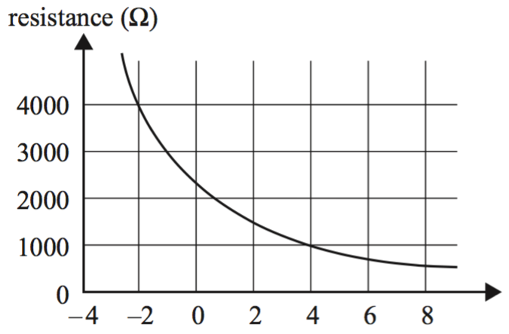

Temperature (°C)

Resistance (Ω)

2000

1500

1000

500

0

(a) Calculate the current in mA that would flow through the thermistor at 4.00 °C if the voltage across it were 2.50 V. Express your answer to 3 significant figures. (3 marks)

|  |  |
| --- | --- |
| **Description** | **Total** |
| Resistance determine on graph = 500 Ω | 1 |
| I = V / R = 2.50 / 500 | 1 |
| = 5.00 mA | 1 |
| **Total** | **3** |
| If not expressed to 3 significant figures maximum 2 marks |  |

(b) Calculate the total current in mA required to flow through the circuit when the temperature is

-2.00 °C in order to meet the required voltage across the resistor. (4 marks)

|  |  |
| --- | --- |
| **Description** | **Total** |
| Resistance determine on graph = 2000 Ω | 1 |
| VT = Vthermistor + Vresistor  Vthermistor = 6.00 – 2.00 = 4.00 V | 1 |
| I = V / R = 4.00 / 2000 | 1 |
| = 2.00 mA | 1 |
| **Total** | **4** |
| If not expressed to 3 significant figures maximum 2 marks |  |

|  |  |
| --- | --- |
| **Section Three: Comprehension** | **8% (12 Marks)** |

**Question 18 (12 marks)**

(a) In the boxes in Figure 1 above, write the correct letter from the options below. (2 marks)

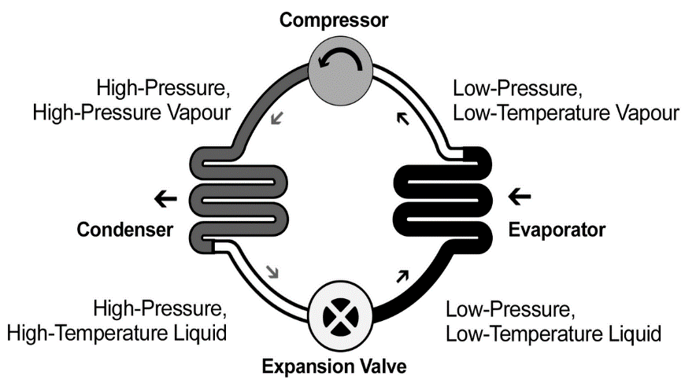

**B**

**A**

|  |  |
| --- | --- |
| **Description** | **Total** |
| Written correctly in boxes. | 1 |
| **Total** | **2** |

(b) In the space below, complete the annotations that would be at parts A, B and C in the diagram. Use Figure 3 to assist you. (3 marks)

|  |  |
| --- | --- |
| **Description** | **Total** |
| A: Refrigerant releases heat to inside air and returns to liquid state. | 1 |
| B: Low pressure low temperature vapour. | 1 |
| C: High pressure, high temperature liquid. | 1 |
| **Total** | **3** |

(c) Calculate the electrical power drawn by the RCAC system. (2 marks)

|  |  |
| --- | --- |
| **Description** | **Total** |
| P = IV  = 11.0 x 240 | 1 |
| = 2,640 W | 1 |
| **Total** | **2** |

(d) Explain, making reference to the final paragraph of the passage, why this input energy (which is less than 8.00 kW for heating) is not violating the law of conservation of energy. (3 marks)

|  |  |
| --- | --- |
| **Description** | **Total** |
| The RCAC is simply moving heat | 1 |
| It can extract heat found in ambient outside air to inside air via use of a refrigerant. | 1 |
| Heat is not being produced, so the input power is not required to be high. | 1 |
| **Total** | **3** |

(e) If an electrical heater was installed and used the same electrical energy as the RCAC system, calculate how the power efficiency of the RCAC system. (2 marks)

|  |  |
| --- | --- |
| **Description** | **Total** |
| = 8.00 x100  2.64 | 1 |
| = 303 % | 1 |
| **Total** | **2** |